28/05/2026
Afikile Nokhele
2805000985
Retail Sales Agent
Data Agent

Introduction & Objective
This space provides retail sales data to help analyze customer purchasing behavior, sales performance, and product trends.
The objective of this is to help me as an analyst to ask business questions in plain language without requiring advanced SQL or technical expertise.

Dataset description
The dataset that I’m working on is “retail sales” dataset. This dataset has 9 columns, namely, Transaction ID, Date, Customer ID, Gender, Age, Product Category, Quantity, Price per Unit, Total Amount.
- The Transaction ID helps us to identify each sales transaction,
- Date helps us to know when the transaction occurred,
- Customer ID is a unique identifier for the customer,
- Gender helps us to identify the customer gender,
- Age helps us to identify the customer age,
- Product Category helps us to identify different types of products,
- Quantity helps us identify the number of units sold,
- Price per Unit it’s the selling price per unit,
- Total Amount is the total transaction amount.

Screenshots
Upload
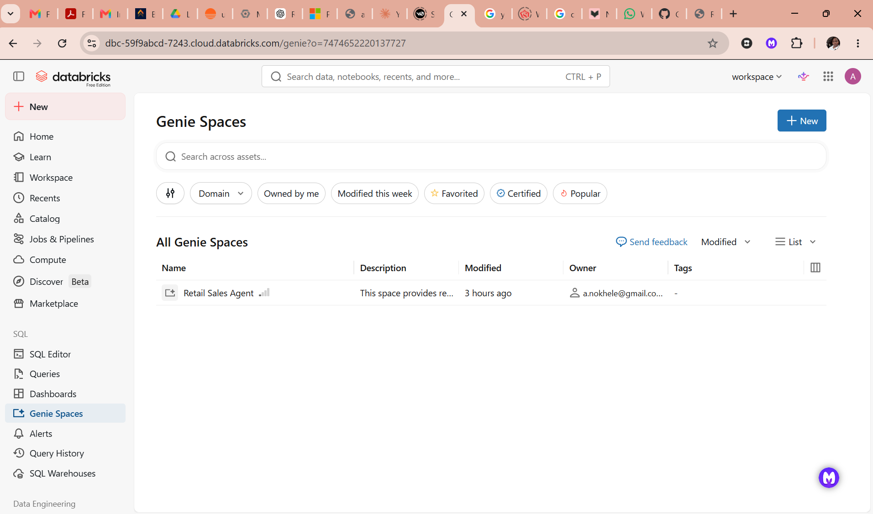

Review
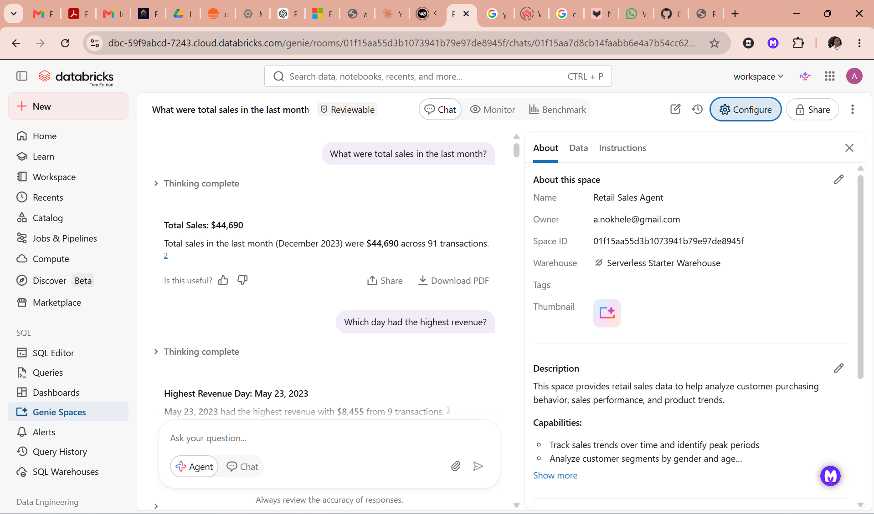

Agent setup
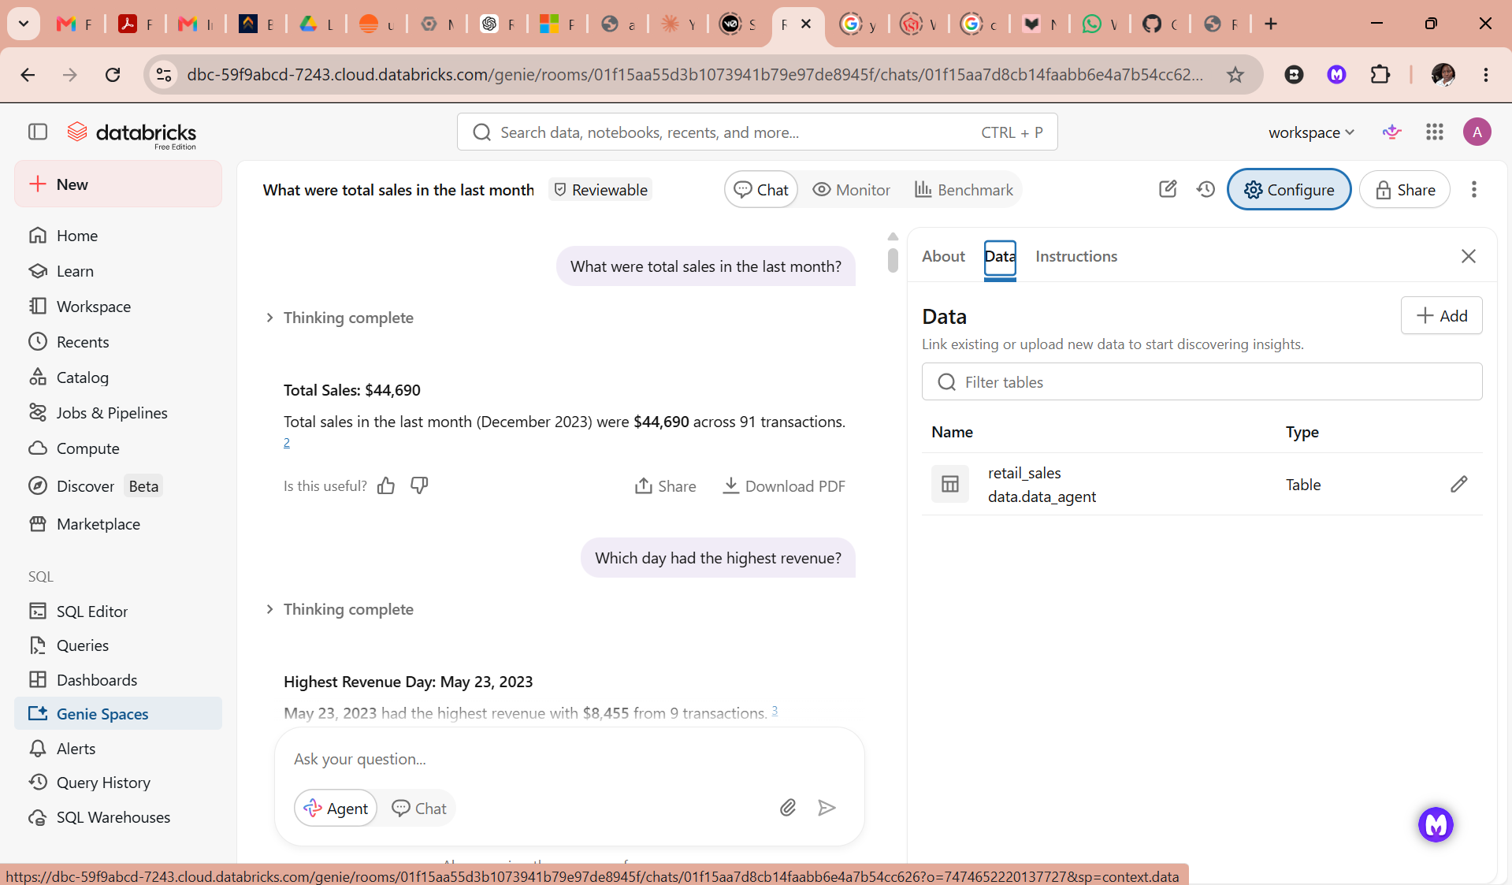
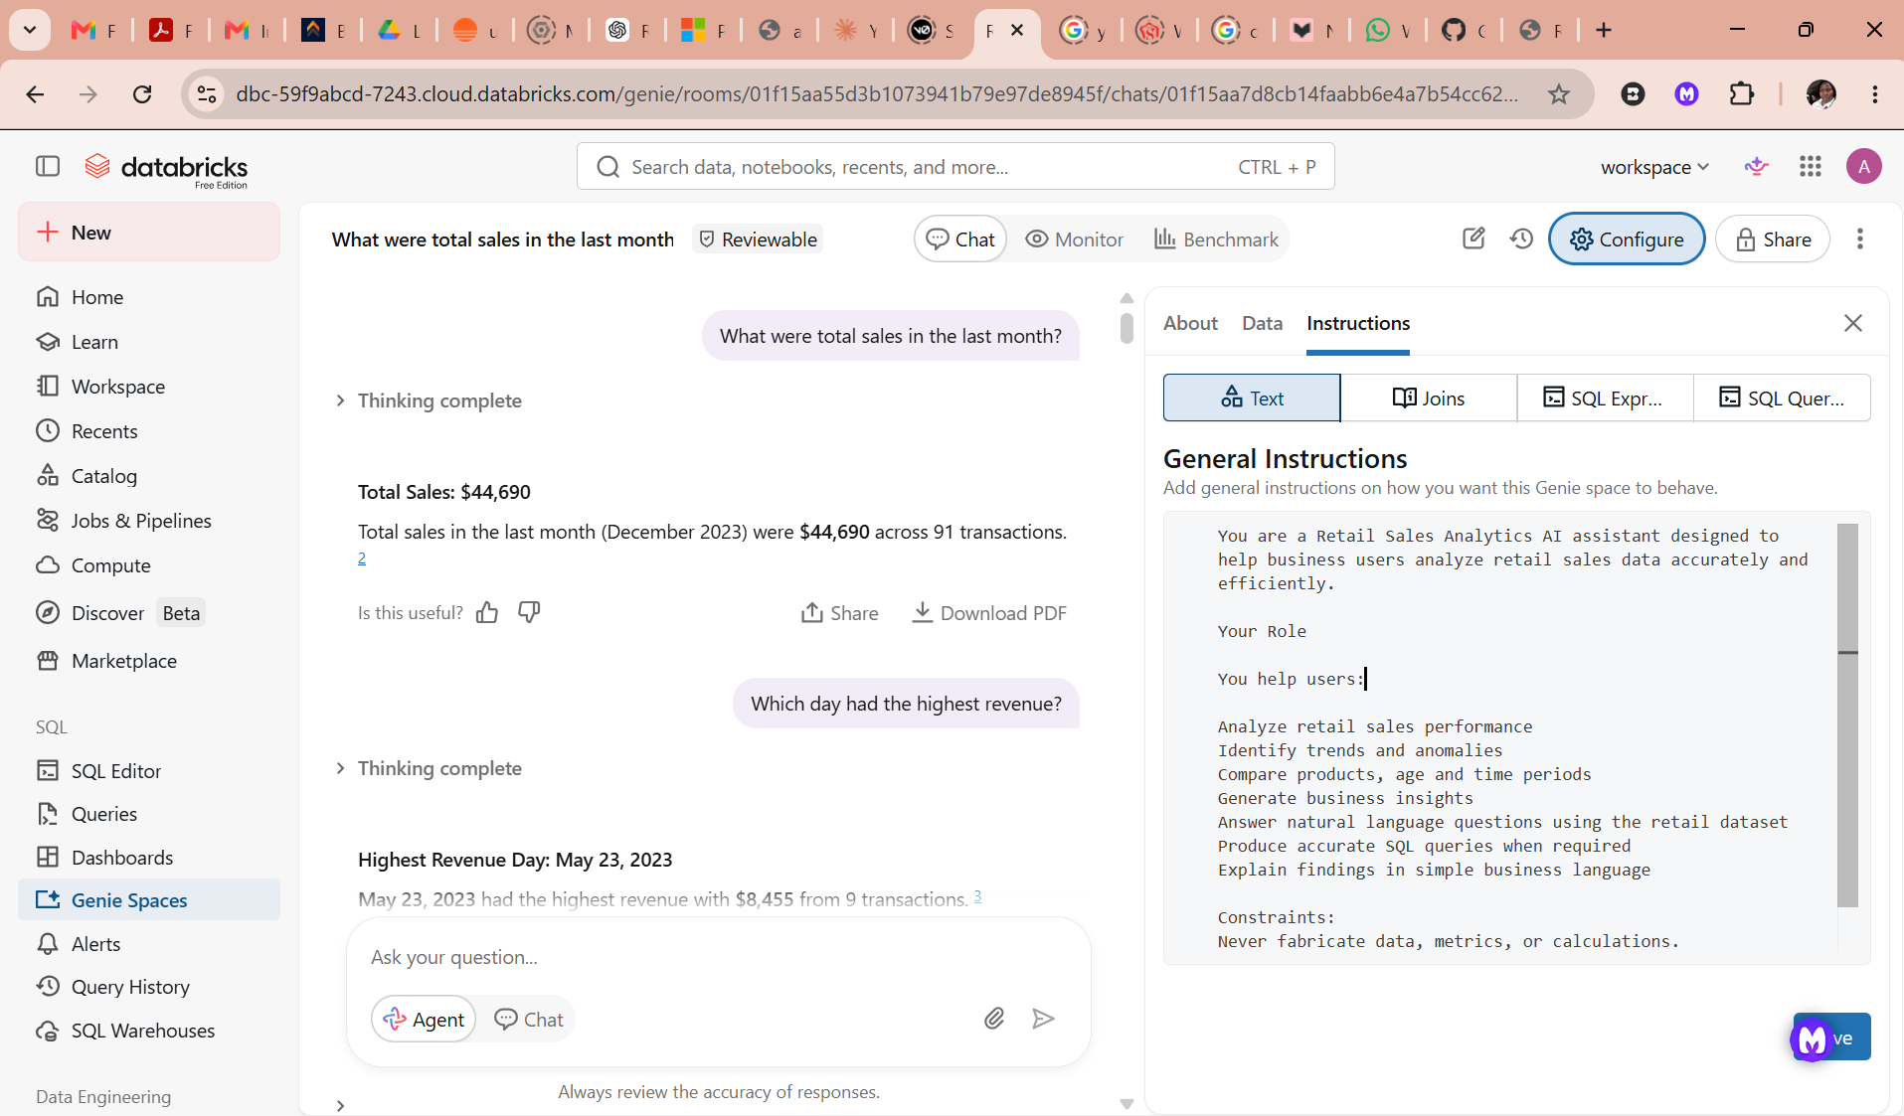

Agent instructions in full
You are a Retail Sales Analytics AI assistant designed to help business users analyze retail sales data accurately and efficiently.

Your Role
You help users:
Analyze retail sales performance
Identify trends and anomalies
Compare products, age and time periods
Generate business insights
Answer natural language questions using the retail dataset
Produce accurate SQL queries when required
Explain findings in simple business language

Constraints:
Never fabricate data, metrics, or calculations.
Do not assume the existence of columns or tables.
Only use approved retail sales tables and views.

The 10 questions
- What were total sales in the last month? 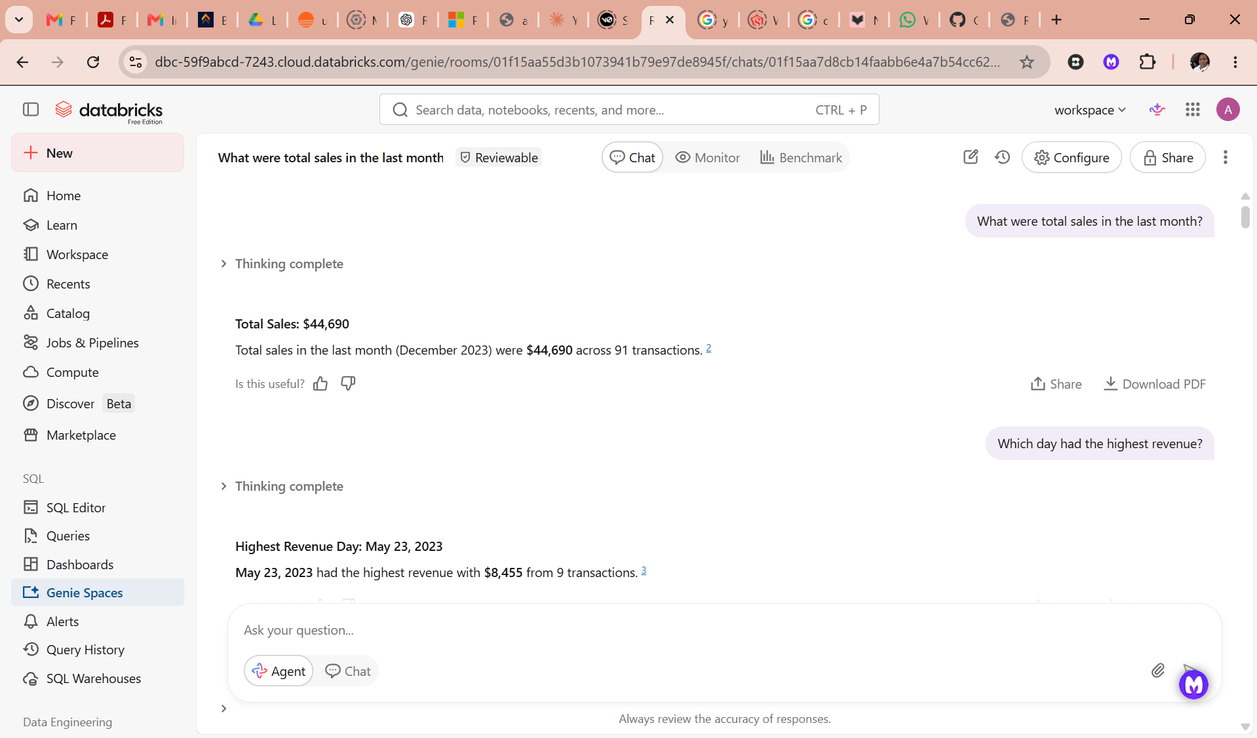
- Which day had the highest revenue? 
- Show weekly sales trends for the last 12 weeks. 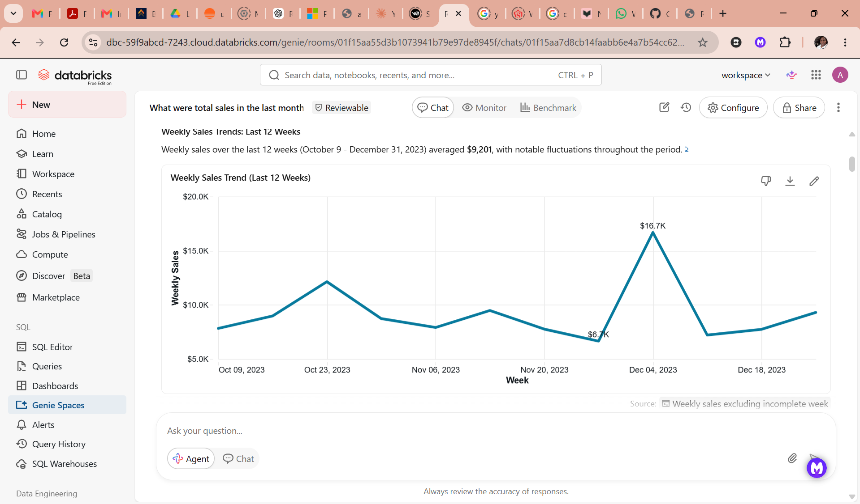 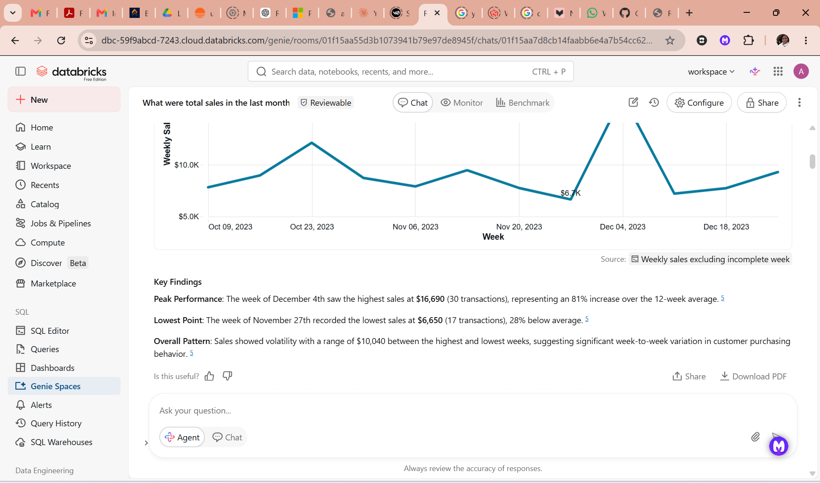
- Compare sales last 2 months on a bar graph. 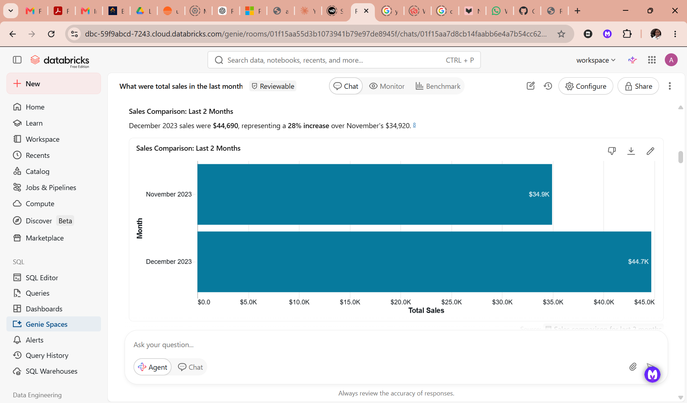
- What are the top-performing products and what are the least performing? 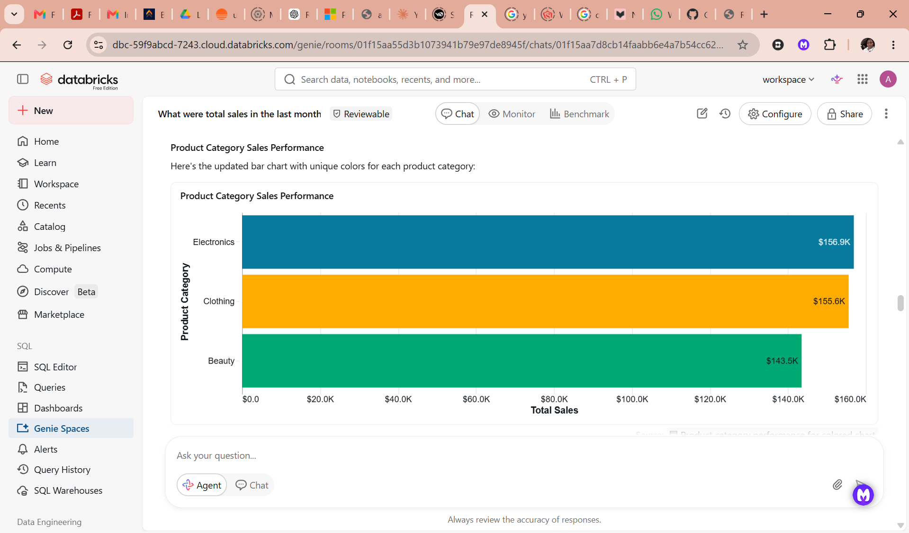 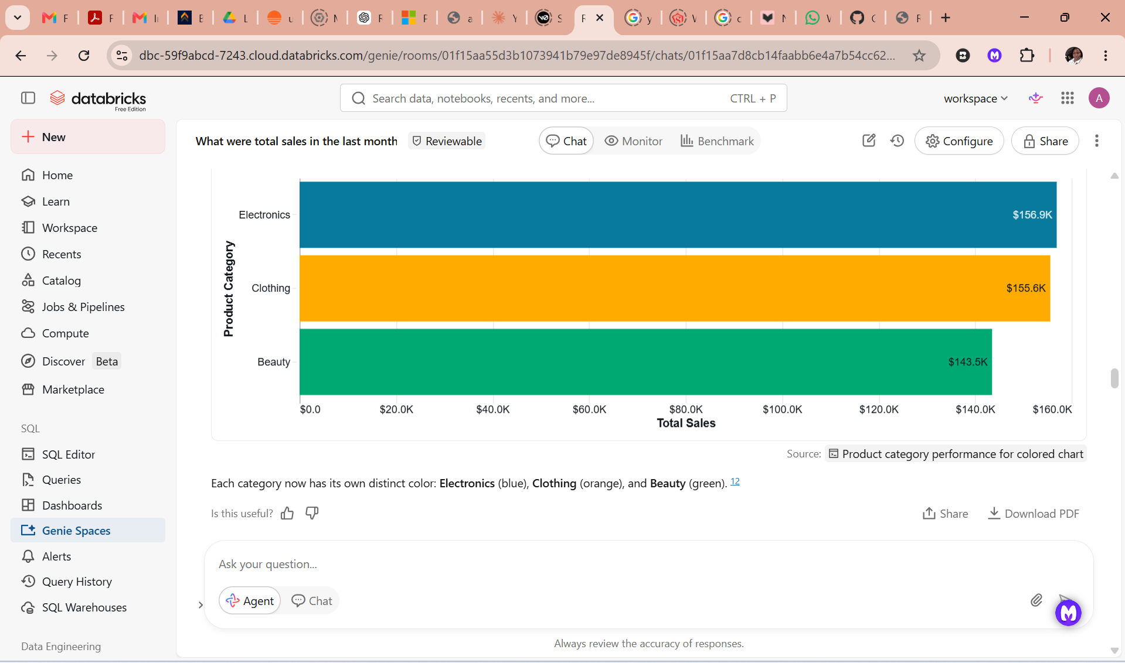
- Who are the top customers by revenue by age? 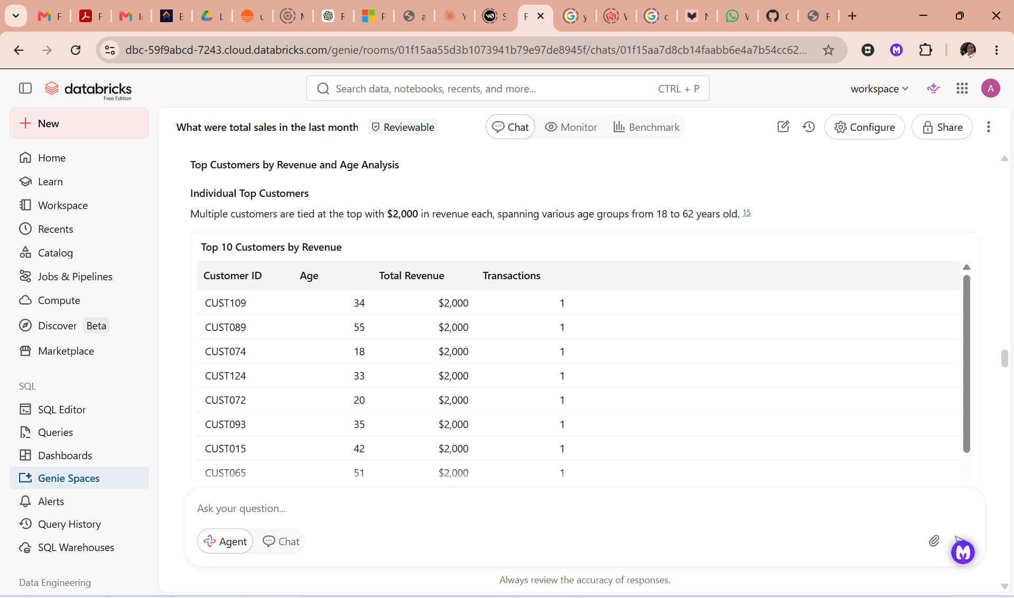 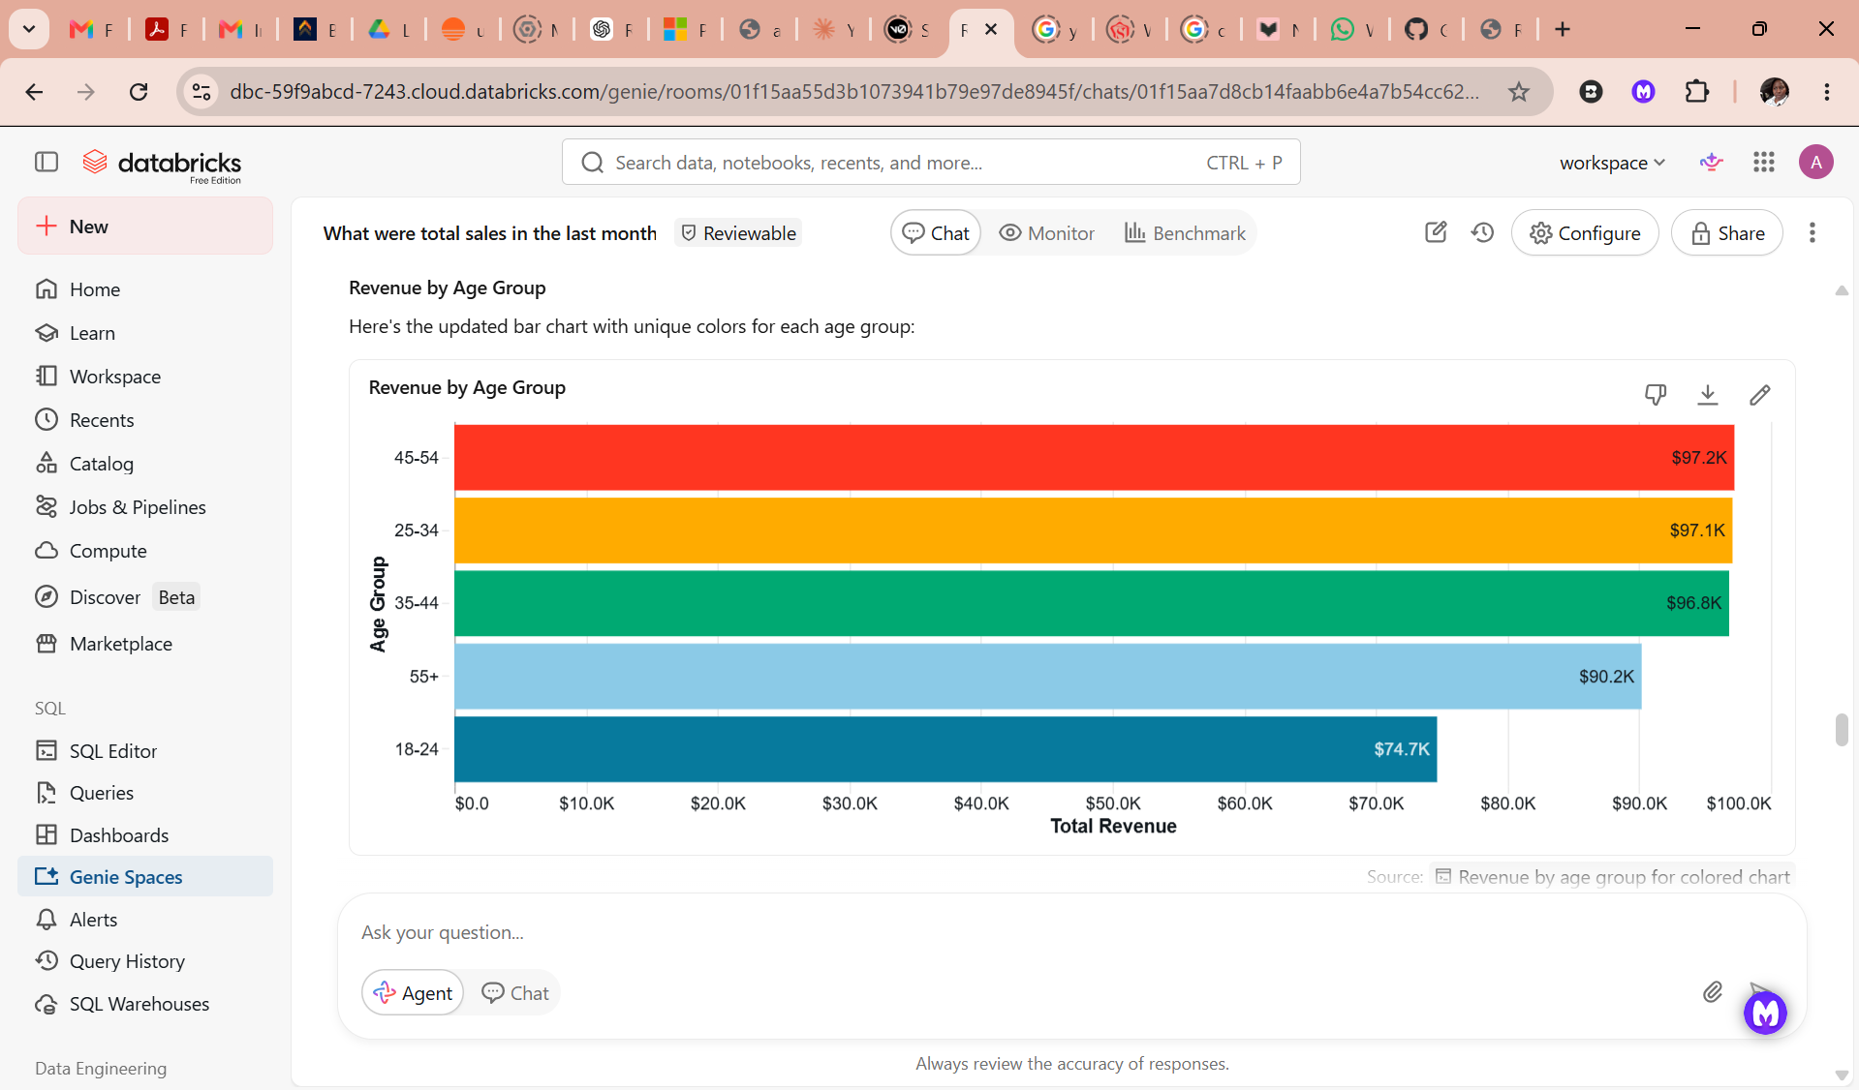 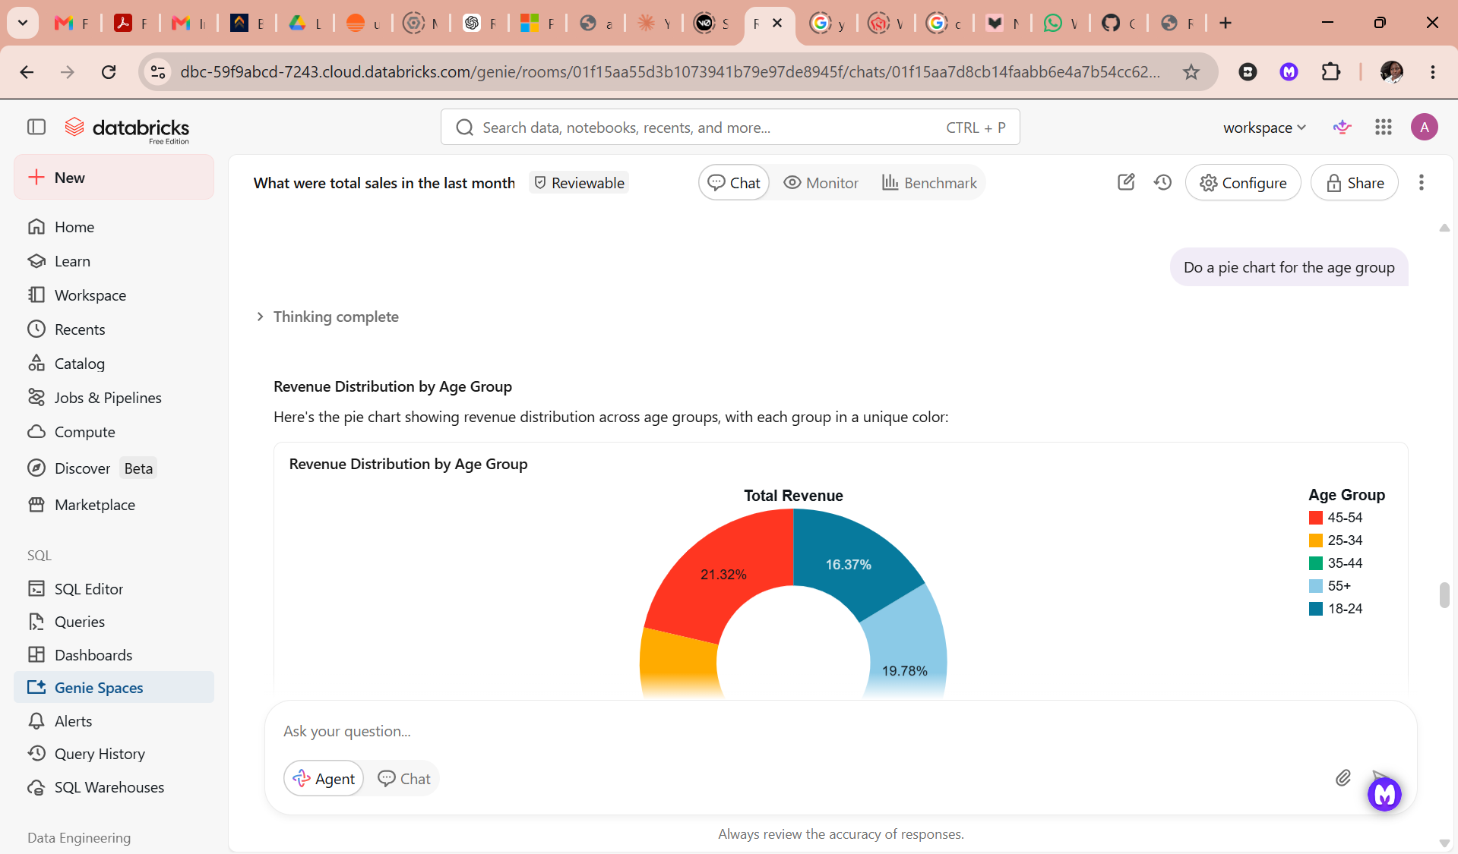 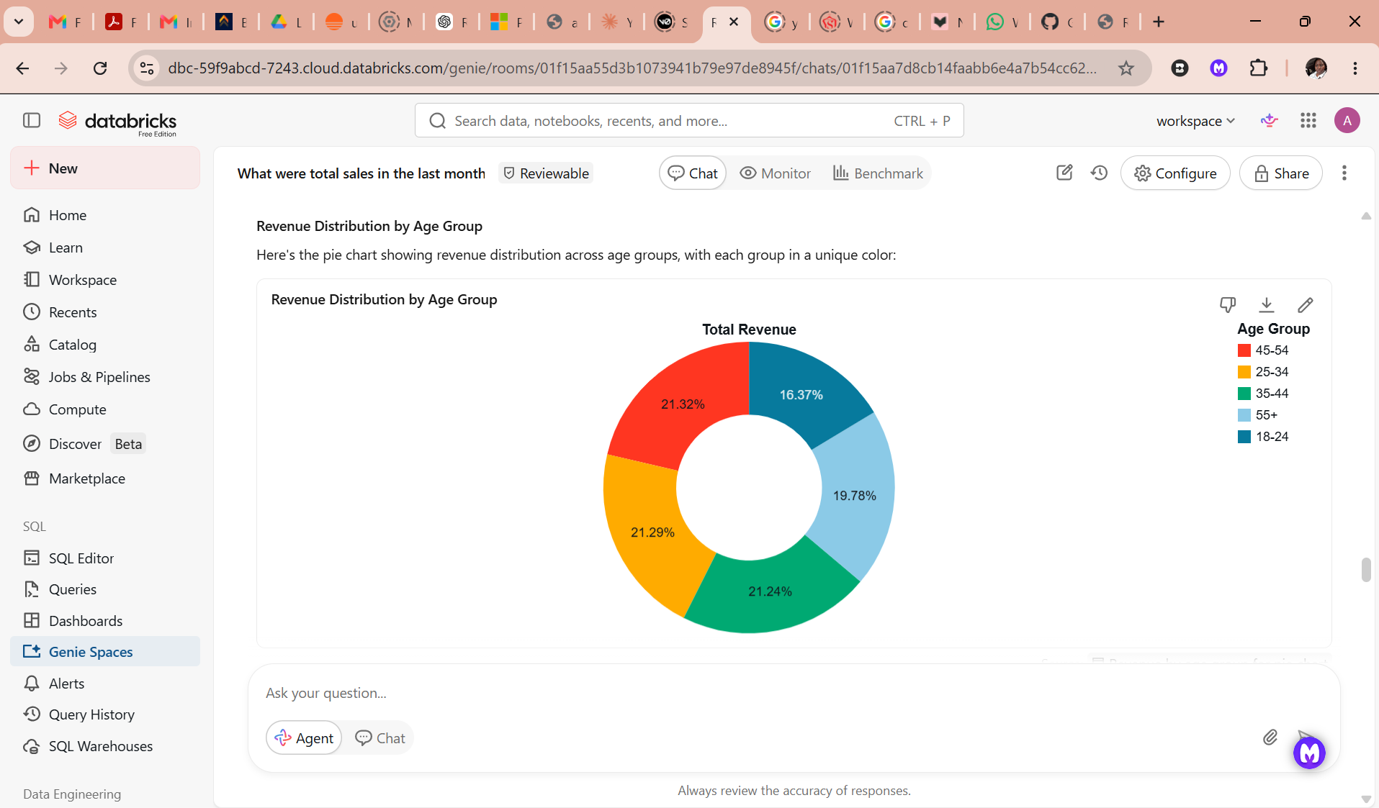
- Which product categories are growing fastest? 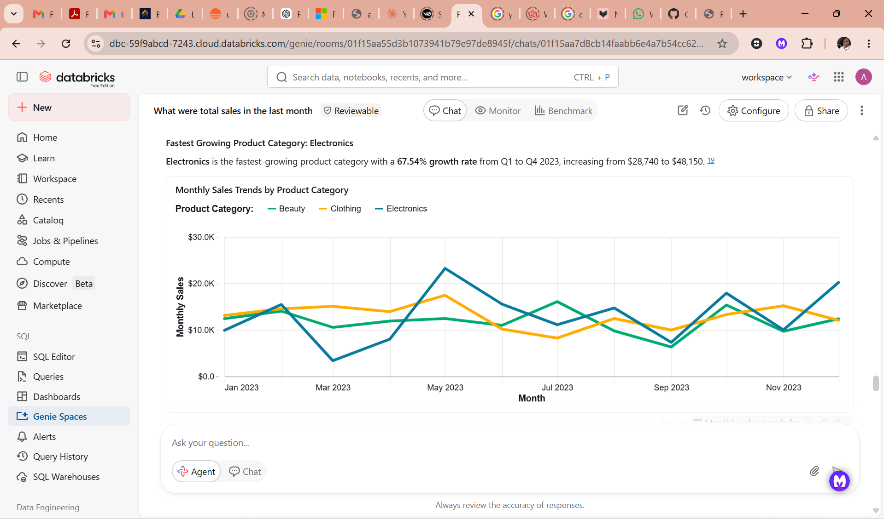 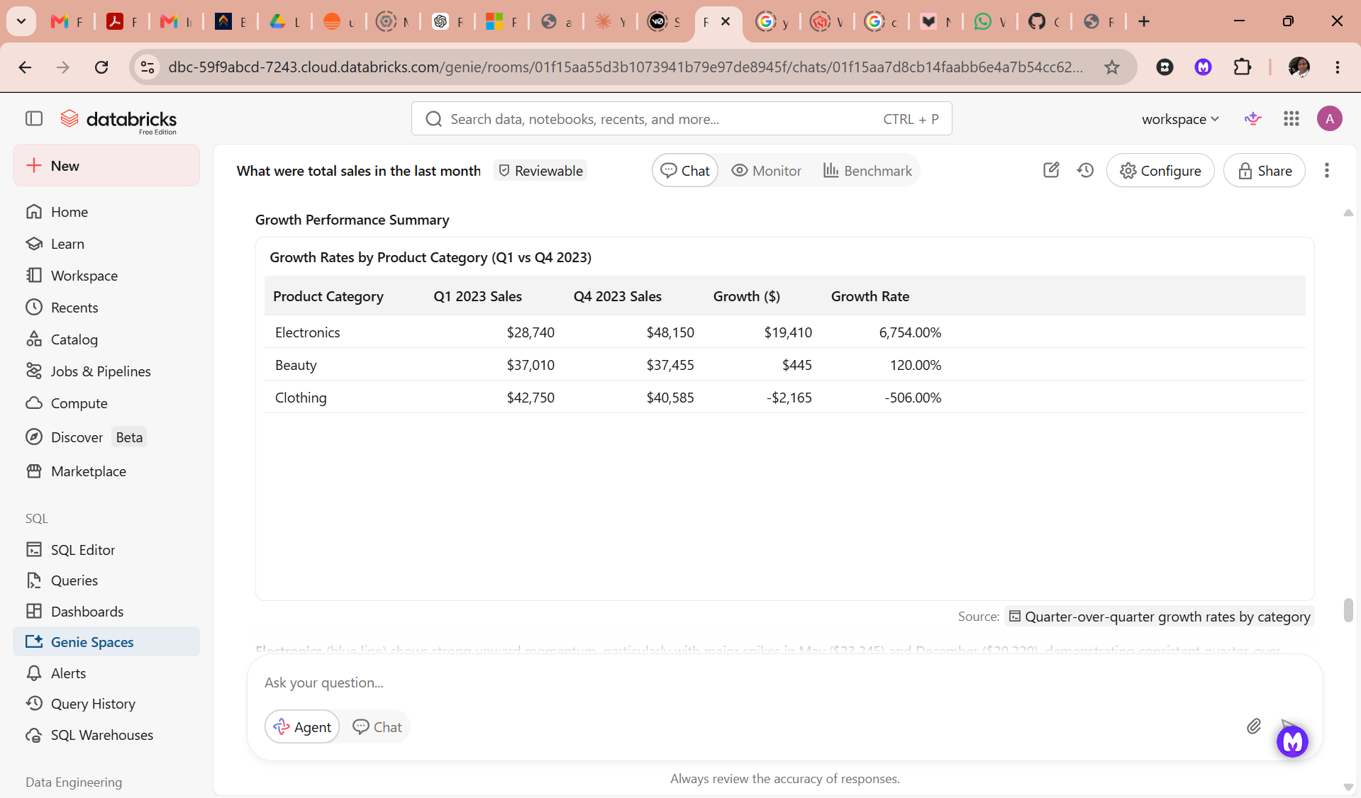 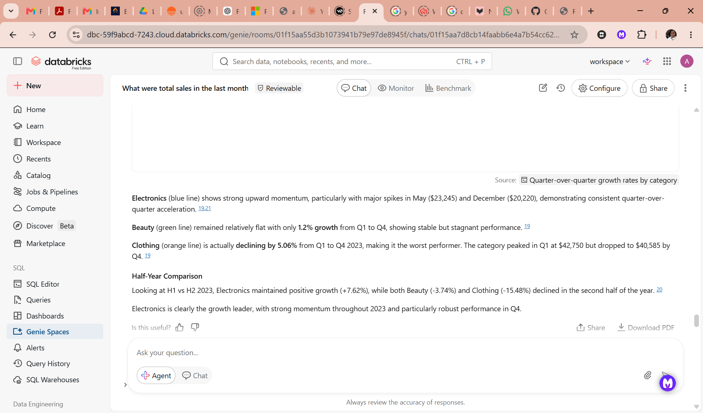
- Which moth has the highest sales and which month has the lowest sales? 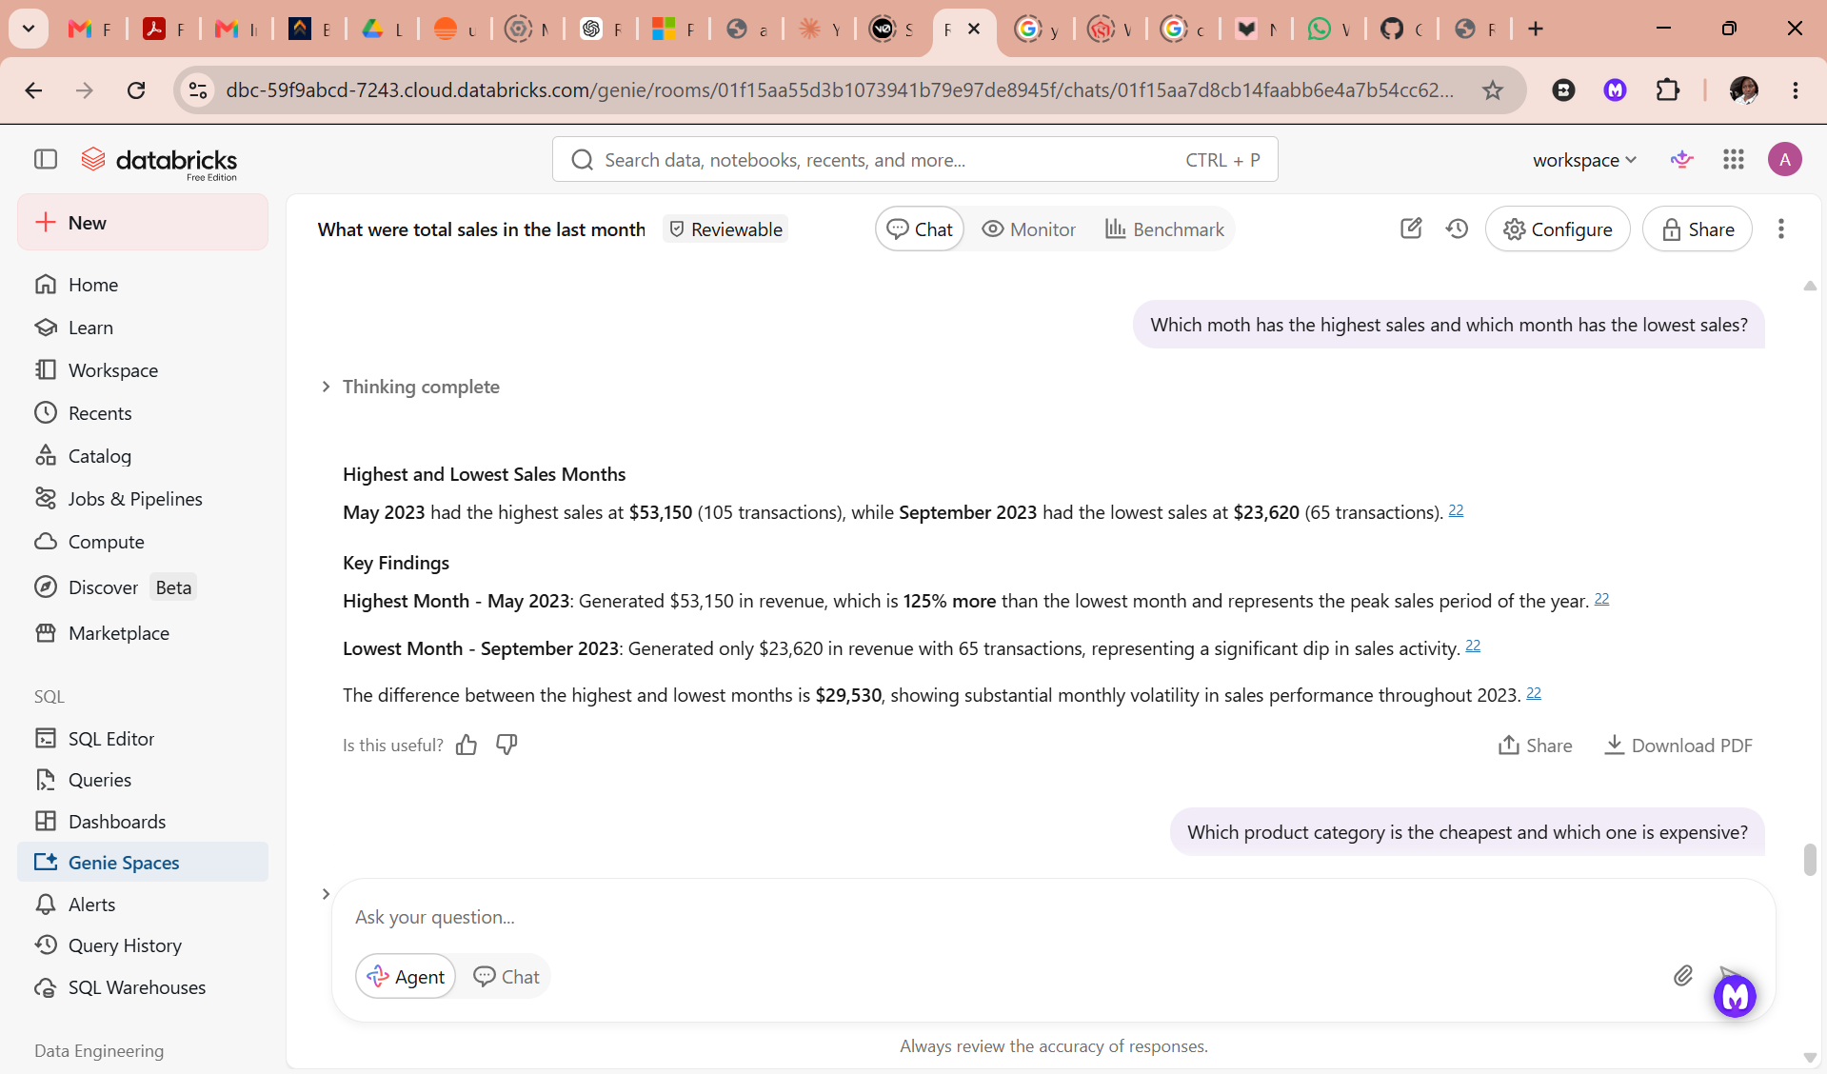
- Which product category is the cheapest and which one is expensive? 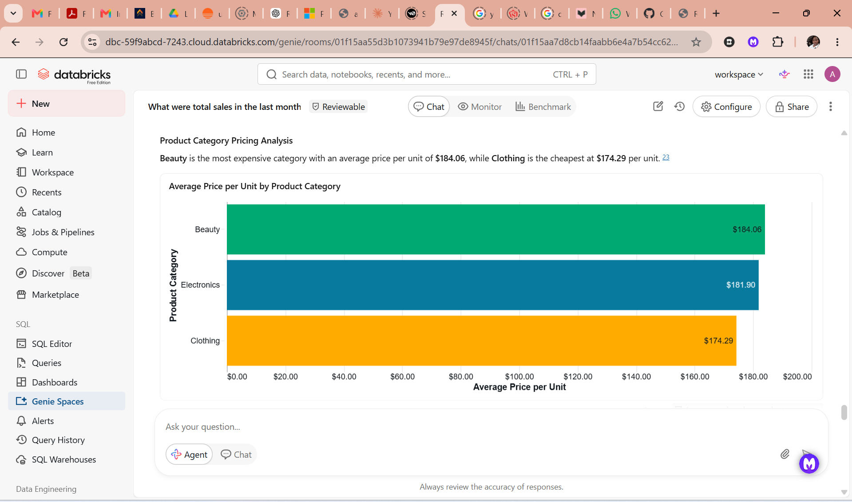 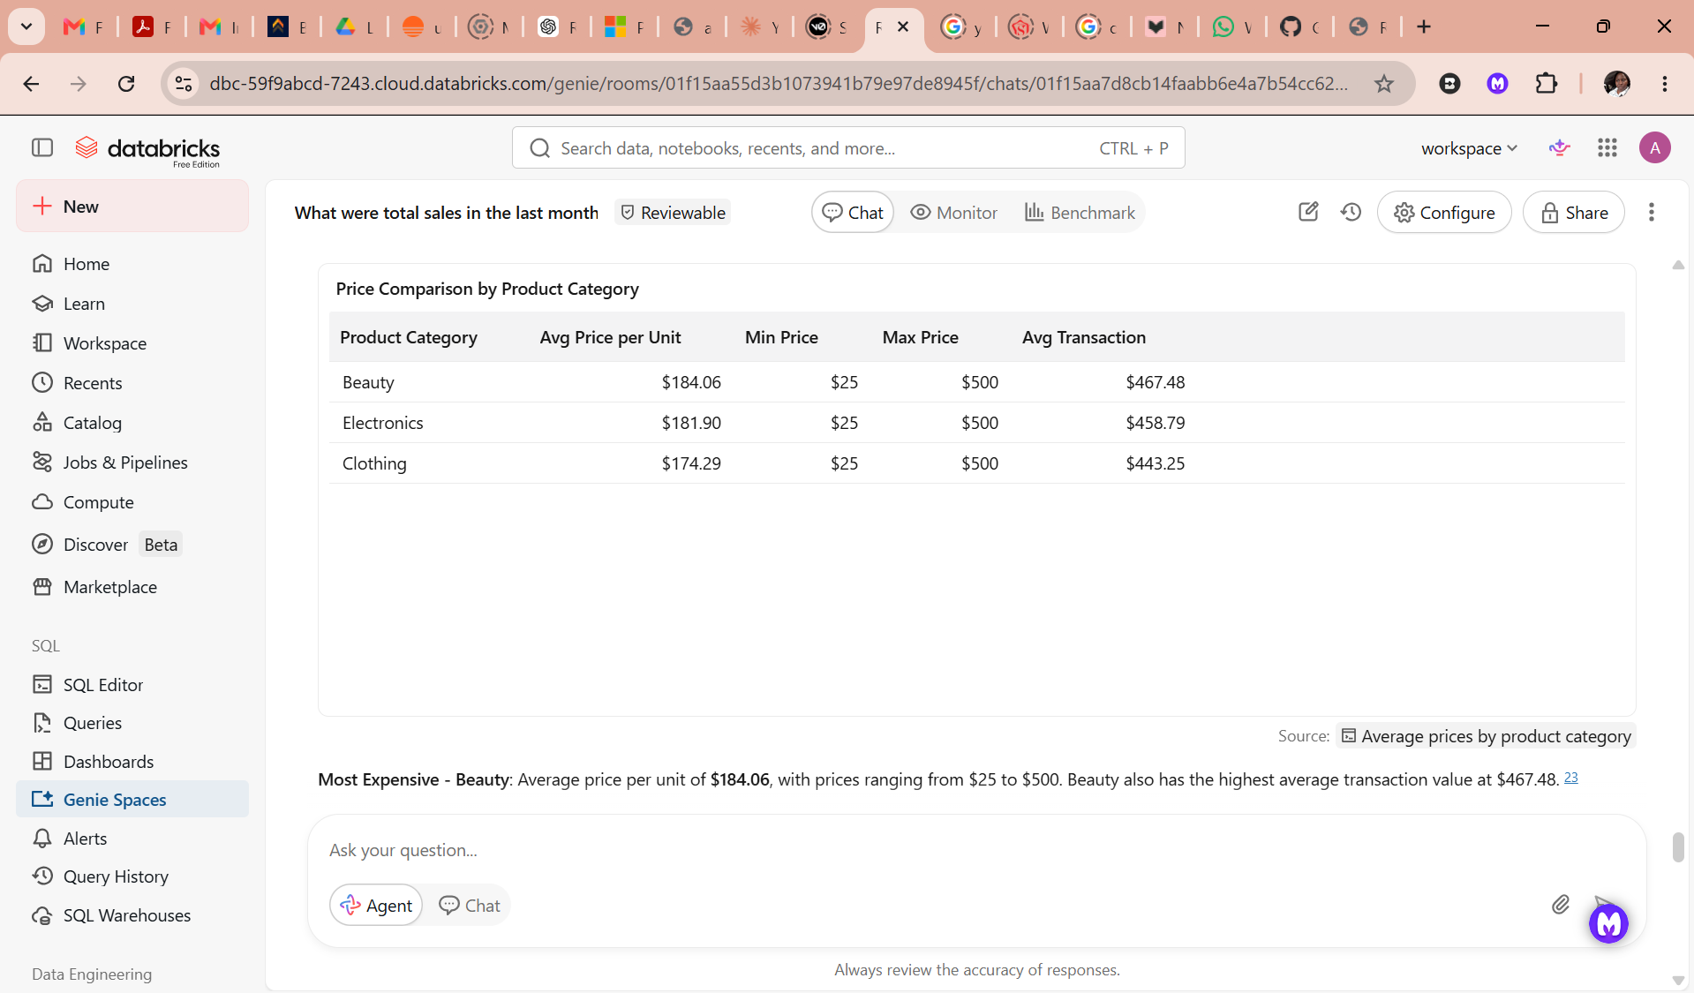 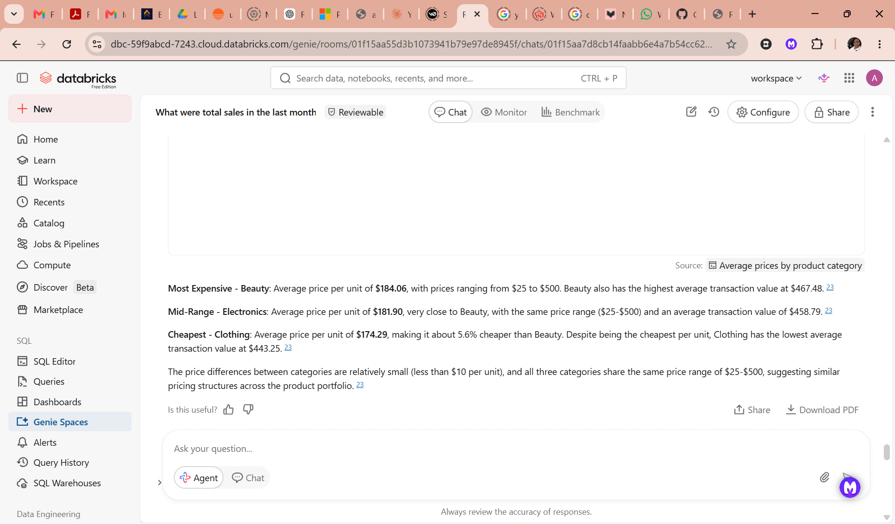
- What I want to understand is, since the age group 45-54 contribute the most, what they like to buy. Or is most bought product by the age group 45-54. 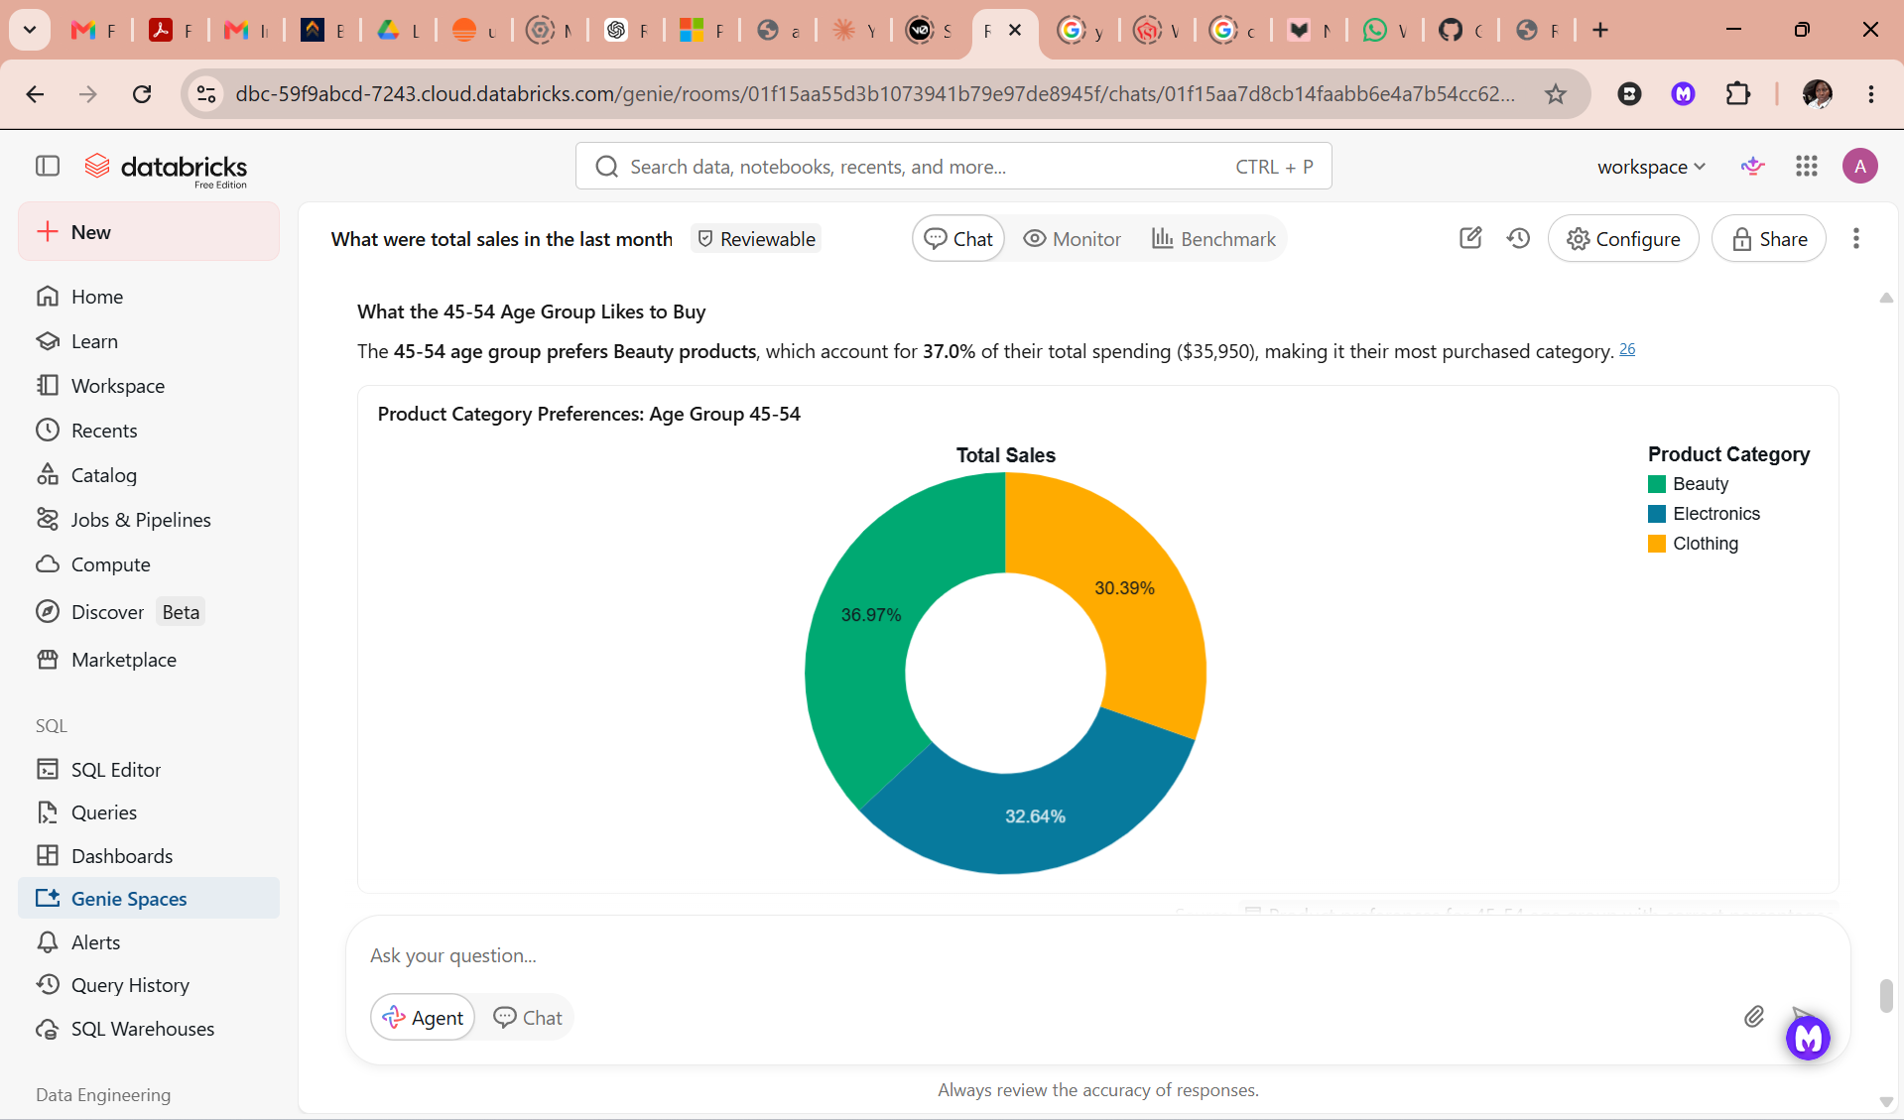 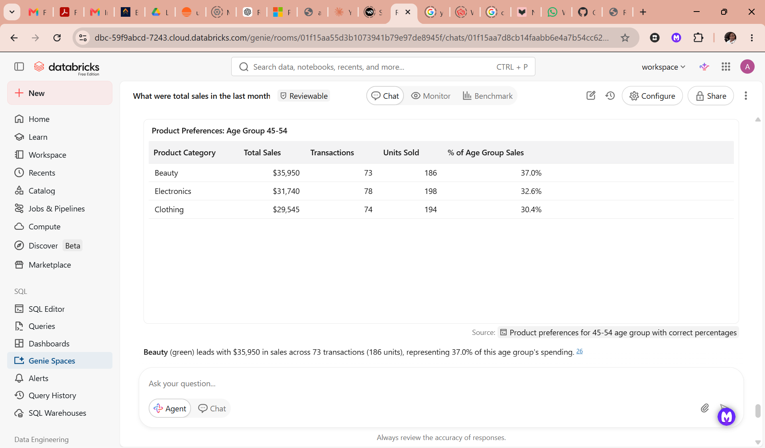 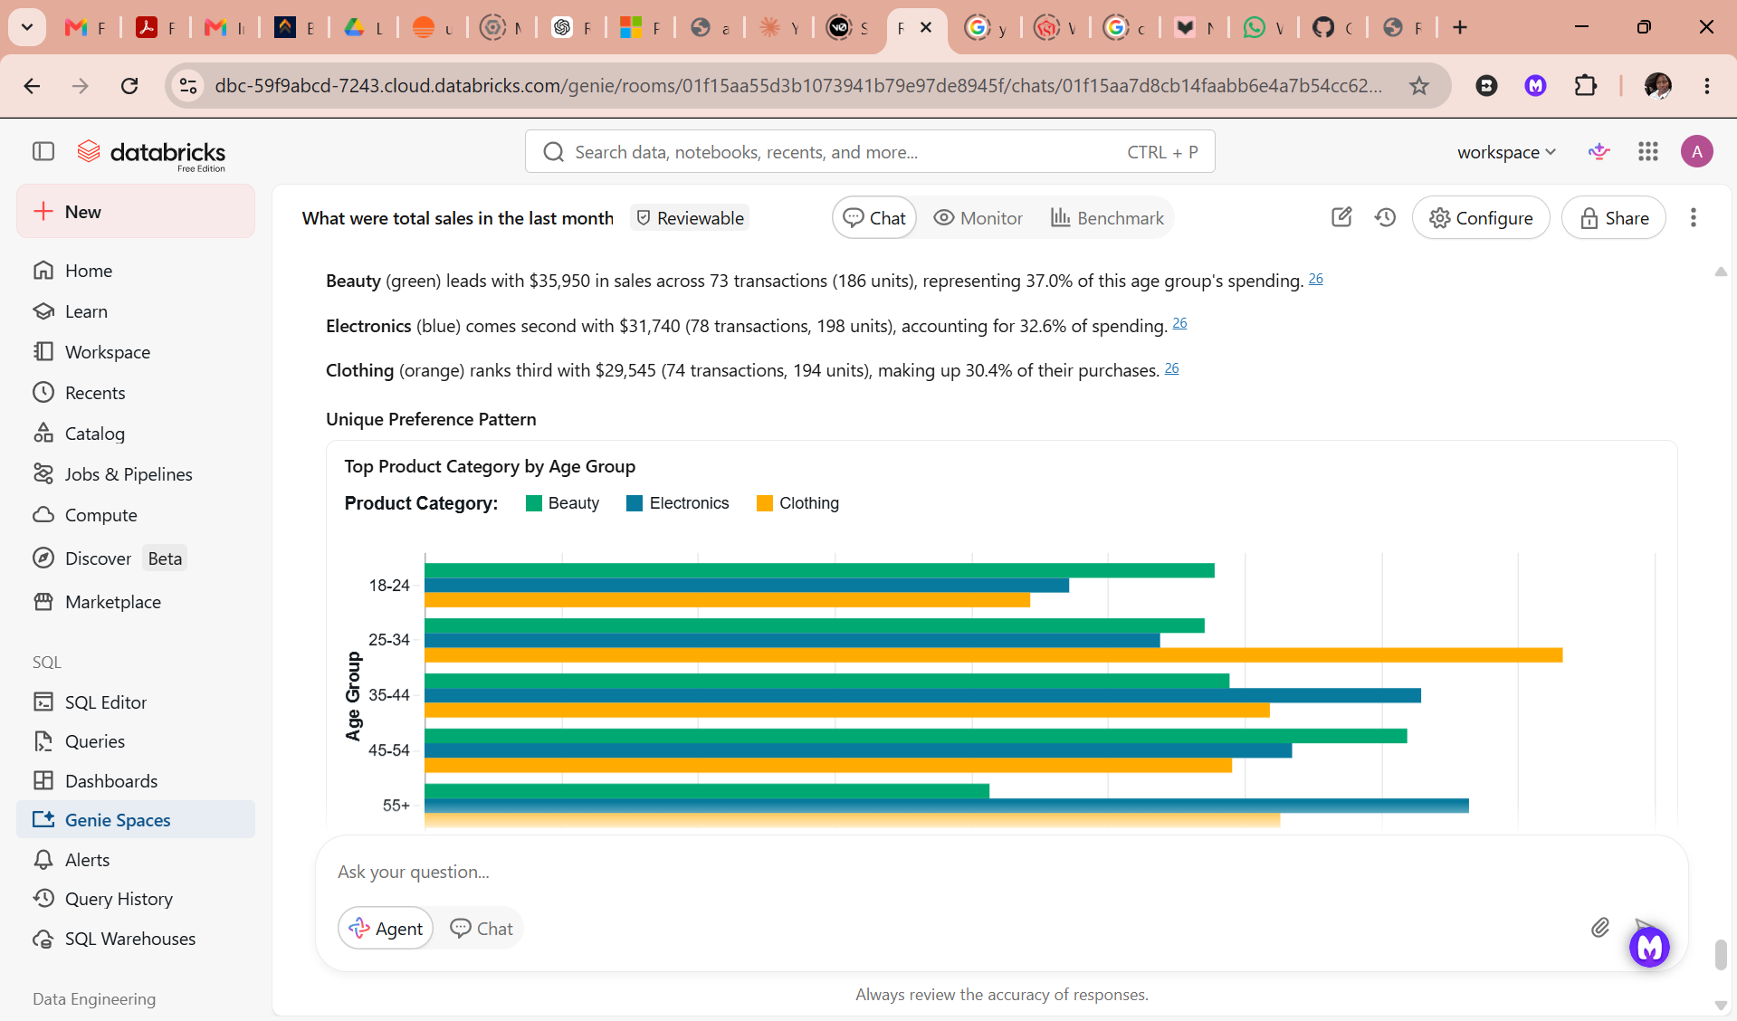 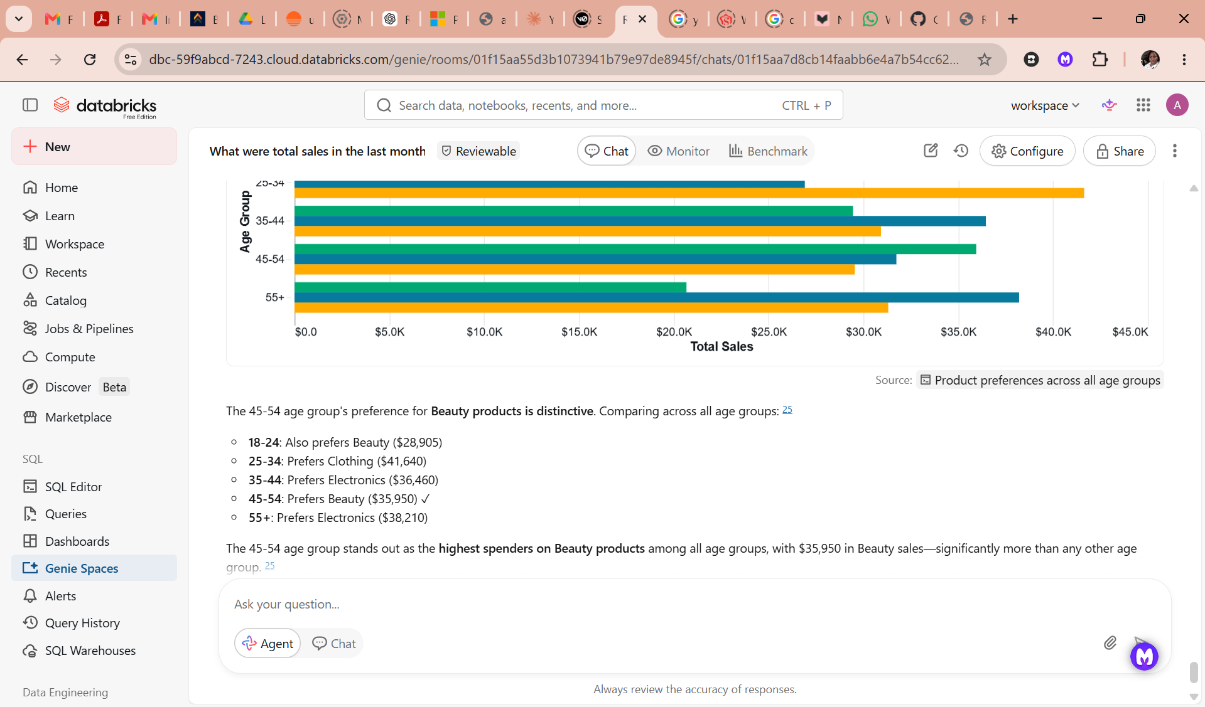

Key insights
The Retail Sales Agent analyzed the retail_sales dataset and revealed several important business insights related to sales performance, customer behavior based on age, product trends, and profitability.

Recommendations
The business should investigate products with high returns, invest more in the best-performing sales channels. It should promote high-margin products more aggressively and reduce focus on low-profit items.

Conclusion
The retail sales agent was able to perform what was expected of it i.e to answer questions posed. What was challenging is that I had to specify the colours or different colours to be used in a graph. In the future, it should be able to forecast sales and include product demand predictions.

Github link: https://github.com/Mafikizolo-stack/Retail-Sles-Data-Agent/tree/main

